1. SYNOPSIS

The Project entitled **“Online Shoe Store”** is a web-based application Software developed in PHP LANGUAGE using Dreamweaver and Browser as front end on Pentium machine.

The main aim of **"Online Shoe Store"** is to improve the services of Customers and vendors. It maintains the details of customer product receipts, addition of new customers, products and also updating, deletion for the same.

It also stores the details of invoices generated by customer with all. The primary features of the project entitled **"Online Shoe Store"** are high accuracy, design flexibility and easy availability. And also it uses database tables Representing entities and relationships between entities.

In The Project Includes these type of modules

* **Modules included**
* **Front End :-**
* Home
* Categories
* Men’s
* Women’s
* Girls Kid’s
* Boys Kid’s
* About Us
* Information About Our Web Site
* Form
* Login Page
* Registration Page
* Forgot Password
* Add to Cart
* **Front End Functionality:-**
* Create New User
* Forgot Password
* Browse categories and Products
* Select a Product
* Checkout
* Enter Order Details(Sender & Receiver)
* Preview Order
* Confirm Order
* **Back EndFunctionality** :-
* **Administrator**
* View & Manage Users
* View & Manage Categories
* View & Manage Products
* View & Manage Orders
* Project scope
* E-commerce use and choose browse shopping and submit. ( User can purchase product online, choose items and administrator can Add, Delete, Update and View all database ).

2. PREAMBLE

* **2.1Project Description**

Use PHP as front end and My SQL as back end. An E- Commerce system integrating latest technologies to read – world development scenarios is made by setting up a full-fledged online shoe store front.

* **Features :-**
  + User registration
  + Browsable product
  + Order management
  + Easy to use
  + Easy to use layout
* **Importance :-**

Any person can choose the product easily and order online without visiting retails store

* **Development tools :-**

**About HTML: -**

The language used to develop a web page is called Hyper Text Mark-up Language (HTML).

HTML is the language which is interpreted by the browser means browser is software knows how to process the web page and how to present them.

Web pages are also called HTML document consist of HTML tags.

These tags are nothing but special code embedded in text to add formatting and linking information.

The HTML tag is a signal to the browser that it should consider them other than just throwing the text up on the screen.

Any HTML tag begins with an open angle bracket (<) and end with close angle bracket (>). [(1)-HTML & CSS]

* **Database Server :-**
* **PHP MYSQL:**

MySQL gives us all advanced facility is in this. Some point are including in this.

* + - * MYSQL Components
      * Technical Support

The database component of MYSQL is a Relation Database System for Internet applications. Each them describes a fundamental part of the architecture of the MYSQL database component:

**Database**

A Database is similar to a data file in that it storage place for data. Like a Database does not present information directly to a user; the user runs an application that fetches data from the database and presents it to the user in an understandable format.

Database Systems are more powerful than data files. In well-designed database, there is no duplicate value of data that the user or application must update at the same time. Related pieces of data are grouped together in a single structure.

A Database typically has two main parts: first, the file holding the physical database and second, the database management system (DBMS) software that application use to fetch and store data. The DBMS is responsible for the Database structure including:

Maintaining relationships between data in the Database.[(2)- Beginning PHP,MYSQL]

* **Website Requirement Analysis**

Requirement Analysis is Understand after the scope of the system to be built. In our project we needed HTML, PHP, and PHPMYSQL.

* **Designing**

Designing is the major part of any Website designing. Proper design and a good GUI is the base of any project.

* **Coding**

The coding for any phase is as needed as the design phase of the project. Coding was the second major task. Coding was done parallel as with the design of the project.

* **Testing**

Testing was done on the regular base during the coding phase itself. Some error that remains uncovered that is done properly at the time of testing. And we get the required output that we want. Large amount of situations create while entering the data during input processing. So, testing is done to get the desired output.[(2)- Beginning PHP,MYSQL]

1. TECHNICAL DESCRIPTION

* **3.1- Hardware Requirement**

Processor : Pentium 4 or Higher

Hard Disk : 40GB

RAM : 512MB or more

* **3.2- Software Requirement**

Operating System : Windows XP

User Interface : HTML, CSS

Client-side Scripting : JavaScript

Programming Language : PHP

IDE/Workbench : Dreamweaver8

Database : MYSQL

Server Deployment : Wamp Server

1. SYSTEM DESIGN & DEVELPOMENT

* **4.1- Data Flow Diagrams**
* Context Level Diagram

Order Acceptance/Rejection

**User**

Customer/Order Billing Detail

Order/Data

Update/ Add

Categories

**Admin**

* DFD Level-1 Diagram

Add Item Orders Order Details

**User**

Order

**New User**

Fill Details

Capturing Info

Update and Place Users

**User**

Order

Check Authentication

Privileged Login

**Admin**

* DFD Level-2 Diagram
* **Cart :-**

Change/Update Catalogue

**Admin**

Browse

**Customer**

Confirmations

Quantity Cart Item

Shopping

Cart

Cart Item

Item Details

Edit Cart

**Customer**

Complete

* **Registration :-**

Login Id/Password

Availability success

Login Availability

Name, detail,

Details Info, email, Mobile

New User

**Profile**

Address, Contact

Addresses

* **Management :-**

Admin

Updated Rates Rates information

**Catalogue**

* **Login :-**

User

**Profile**

Login

Information Users

Details

User name

Password Authentication

Invalid Login

**4.2- Database Design**

|  |  |  |  |
| --- | --- | --- | --- |
| Fields | Data Type | Size | Constraints |
| cart_id | Int | 10 | Primary_key,  auto_increment, NotNull |
| Cart_session | Varchar | 100 | NotNull |
| item_id | Int | 10 | NotNull |
| item_price | Float | 50 | NotNull |
| item_name | Varchar | 100 | NotNull |
| item_quality | Int | 2 | NotNull |
| item_total_price | Float | 50 | NotNull |
| item_image | Varchar | 100 | NotNull |
| cart_status | Varchar | 10 | NotNull |
| Order_id | Varchar | 10 | NotNull |

|  |  |  |  |
| --- | --- | --- | --- |
| Fields | Data Type | Size | Constraints |
| Address_id | Int | 10 | Primary_key,  auto_increment, NotNull |
| Order_id | Int | 10 | NotNull |
| Address1 | Varchar | 100 | NotNull |
| Address2 | Varchar | 100 | NotNull |
| City | Varchar | 20 | NotNull |
| Country | Varchar | 20 | NotNull |
| Post_code | Varchar | 20 | NotNull |

|  |  |  |  |
| --- | --- | --- | --- |
| Fields | Data Type | Size | Constraints |
| Cat_id | Int | 10 | Primary_key,  auto_increment, NotNull |
| Cat_name | Varchar | 30 | NotNull |
| Status | Varchar | 1 | NotNull |

|  |  |  |  |
| --- | --- | --- | --- |
| Fields | Data Type | Size | Constraints |
| Id | Int | 10 | Primary_key, NotNull,AutoIncrement |
| Name | Varchar | 30 | NotNull |
| Country | Varchar | 30 | NotNull |
| Totalorders | Varchar | 10 | NotNull |
| Ratings | Varchar | 1 | NotNull |
| Testimonial | Text |  | NotNull |
| Date | Varchar | 30 | NotNull |
| Approved | Varchar | 1 | NotNull |

|  |  |  |  |
| --- | --- | --- | --- |
| Fields | Data Type | Size | Constraints |
| Order_id | Int(10) | 10 | Primary_key,auto_increment, NotNull |
| Cart_session | Varchar(100) | 100 | NotNull |
| User_id | Varchar(20) | 20 | NotNull |
| Sub_total | Varchar(10) | 10 | NotNull |
| Vat | Varchar(10) | 10 | NotNull |
| Total_price | Double | 50 | NotNull |
| Order_date | Varchar(50) | 50 | NotNull |
| Shipment_date | Varchar(50) | 50 | NotNull |
| Order_status | Varchar(15) | 15 | NotNull |
| Ipaddress | Varchar(30) | 30 | NotNull |

|  |  |  |  |
| --- | --- | --- | --- |
| Fields | Data Type | Size | Constraints |
| City_id | Int | 11 | Primary_key,  auto_increment, NotNull |
| City_name | Varchar | 255 | NotNull |

|  |  |  |  |
| --- | --- | --- | --- |
| Fields | Data Type | Size | Constraints |
| Admin_id | Int | 4 | UNIQUE,NotNull,  auto_increment |
| Username | Varchar | 15 | NotNull |
| Password | Varchar | 15 | NotNull |

|  |
| --- |
| Wg_admin |
|  |
| Wg_cart |
| Wg_category |
| Wg_cities |
|  |
| Wg_items |
| Wg_orders |
| Wg_order_message |
| Wg_testimonial |
| Wg_users |

|  |  |  |  |
| --- | --- | --- | --- |
| Fields | Data Type | Size | Constraints |
| Id | Int(10) | 10 | Primary_key,  auto_increment, NotNull |
| Order_id | Int(10) | 10 | NotNull |
| Message | Text | 50 | NotNull |
| Sender | Varchar(10) | 10 | NotNull |
| Sentdate | Varchar(15) | 15 | NotNull |

|  |  |  |  |
| --- | --- | --- | --- |
| Fields | Data Type | Size | Constraints |
| User_id | Int(11) | 11 | Primary_key,  auto_increment, NotNull |
| Full_name | Varchar(100) | 100 | NotNull |
| User_pass | Varchar(10) | 10 | NotNull |
| Email | Varchar(100) | 100 | NotNull |
| Date_joined | Varchar(50) | 50 | NotNull |
| Company_name | Char(20) | 20 | NotNull |
| Account_type | Varchar(20) | 20 | NotNull |

|  |  |  |  |
| --- | --- | --- | --- |
| Fields | Data Type | Size | Constraints |
| Cat_id | Int(10) | 10 | NotNull |
| Item_id | Bigint(20) | 20 | Primary_key,auto_increment, NotNull |
| Item_name | Varchar(250) | 250 | NotNull |
| Item_price | Float | 50 | NotNull |
| Item_desc | Text | 100 | NotNull |
| Item_status | Tinyint(1) | 1 | NotNull |
| Thumbnail | Varchar(100) | 100 | NotNull |
| Big_image | Varchar(100) | 100 | NotNull |
| Medium_image | Varchar(100) | 100 | NotNull |
| Item_stock | Int(10) | 10 | NotNull |

* **4.2.1- Table Structure**
* **wg_address table :-**

|  |  |  |  |
| --- | --- | --- | --- |
| Fields | Data Type | Size | Constraints |
| Address_id | Int | 10 | Primary_key,auto_increment, NotNull |
| Order_id | Int | 10 | NotNull |
| Address1 | Varchar | 100 | NotNull |
| Address2 | Varchar | 100 | NotNull |
| City | Varchar | 20 | NotNull |
| Country | Varchar | 20 | NotNull |
| Post_code | Varchar | 20 | NotNull |

It Stores Customers Address Id, Order Id, Address, City, Country, Pin Code all Details of customer.

* **wg_admin table :-**

|  |  |  |  |
| --- | --- | --- | --- |
| Fields | Data Type | Size | Constraints |
| Admin_id | Int | 4 | UNIQUE, NotNull,auto_increment |
| Username | Varchar | 15 | NotNull |
| Password | Varchar | 15 | NotNull |

It Stores Admin Username and Password for the admin login purpose. Admin give the same username and password he/she can store than and then they can login.

* **wg_cart table :-**

|  |  |  |  |
| --- | --- | --- | --- |
| Fields | Data Type | Size | Constraints |
| cart_id | Int | 10 | Primary_key,auto_increment, NotNull |
| Cart_session | Varchar | 100 | NotNull |
| item_id | Int | 10 | NotNull |
| item_price | Float | 50 | NotNull |
| item_name | Varchar | 100 | NotNull |
| item_quality | Int | 2 | NotNull |
| item_total_price | Float | 50 | NotNull |
| item_image | Varchar | 100 | NotNull |
| cart_status | Varchar | 10 | NotNull |
| Order_id | Varchar | 10 | NotNull |

It Stores Details of these products that can selected by user. It store cart id, cart session, item id, item price, item name, item quality, item total price, item image, cart status, and order id .

* **wg_categories table :-**

|  |  |  |  |
| --- | --- | --- | --- |
| Fields | Data Type | Size | Constraints |
| Cat_id | Int | 10 | Primary_key,auto_increment, NotNull |
| Cat_name | Varchar | 30 | NotNull |
| Status | Varchar | 1 | NotNull |

It Stores Categories Id, Name, Status for user interaction. And user only See these categories.

* **wg_cities table :-**

|  |  |  |  |
| --- | --- | --- | --- |
| Fields | Data Type | Size | Constraints |
| City_id | Int | 11 | Primary_key,auto_increment, NotNull |
| City_name | Varchar | 255 | NotNull |

It Stores Cities name in database that can be entered by user.

* **wg_items table :-**

|  |  |  |  |
| --- | --- | --- | --- |
| Fields | Data Type | Size | Constraints |
| Cat_id | Int(10) | 10 | NotNull |
| Item_id | Bigint(20) | 20 | Primary_key,auto_increment, NotNull |
| Item_name | Varchar(250) | 250 | NotNull |
| Item_price | Float | 50 | NotNull |
| Item_desc | Text | 100 | NotNull |
| Item_status | Tinyint(1) | 1 | NotNull |
| Thumbnail | Varchar(100) | 100 | NotNull |
| Big_image | Varchar(100) | 100 | NotNull |
| Medium_image | Varchar(100) | 100 | NotNull |
| Item_stock | Int(10) | 10 | NotNull |

It Stores items id, name, price, description, status, thumbnail, big image, medium image, Item stock. For user interaction purpose.

* **wg_orders table :-**

|  |  |  |  |
| --- | --- | --- | --- |
| Fields | Data Type | Size | Constraints |
| Order_id | Int(10) | 10 | Primary_key,auto_increment, NotNull |
| Cart_session | Varchar(100) | 100 | NotNull |
| User_id | Varchar(20) | 20 | NotNull |
| Sub_total | Varchar(10) | 10 | NotNull |
| Vat | Varchar(10) | 10 | NotNull |
| Total_price | Double | 50 | NotNull |
| Order_date | Varchar(50) | 50 | NotNull |
| Shipment_date | Varchar(50) | 50 | NotNull |
| Order_status | Varchar(15) | 15 | NotNull |
| Ipaddress | Varchar(30) | 30 | NotNull |

It Stores Orders that given by user. It stores Order id, cart session, user id, subtotal, vat, total price, order date, shipment date, order status, ipaddress.

* **wg_order_messages table :-**

|  |  |  |  |
| --- | --- | --- | --- |
| Fields | Data Type | Size | Constraints |
| Id | Int(10) | 10 | Primary_key,auto_increment, NotNull |
| Order_id | Int(10) | 10 | NotNull |
| Message | Text | 50 | NotNull |
| Sender | Varchar(10) | 10 | NotNull |
| Sentdate | Varchar(15) | 15 | NotNull |

It Stores Ordered Message that can send by user. It stores order id, message, sender ip, sent date all data are stored in database.

* **wg_testimonials table :-**

|  |  |  |  |
| --- | --- | --- | --- |
| Fields | Data Type | Size | Constraints |
| Id | Int | 10 | Primary_key, NotNull,AutoIncrement |
| Name | Varchar | 30 | NotNull |
| Country | Varchar | 30 | NotNull |
| Totalorders | Varchar | 10 | NotNull |
| Ratings | Varchar | 1 | NotNull |
| Testimonial | Text |  | NotNull |
| Date | Varchar | 30 | NotNull |
| Approved | Varchar | 1 | NotNull |

It Stores testimonials or feedback for our web site that can give by user. All details of user id, name, country, total orders, Rating, testimonial, date, approved are stored.

* **wg_users table :-**

|  |  |  |  |
| --- | --- | --- | --- |
| Fields | Data Type | Size | Constraints |
| User_id | Int(11) | 11 | Primary_key,auto_increment, NotNull |
| Full_name | Varchar(100) | 100 | NotNull |
| User_pass | Varchar(10) | 10 | NotNull |
| Email | Varchar(100) | 100 | NotNull |
| Date_joined | Varchar(50) | 50 | NotNull |
| Company_name | Char(20) | 20 | NotNull |
| Account_type | Varchar(20) | 20 | NotNull |

It Stores users is, full name, User password, Email, Date for joined these account, Company name, Account Type.

1. SYSTEM TESTING

**Test Case - 1**

|  |  |
| --- | --- |
| Page | Login |
| Description | User wants to login |
| Validation | Enter Full name , password must be in 6 characters |
| Input | User name, password |
| Result | Successfully login |

**Test Case – 2**

|  |  |
| --- | --- |
| Page | Register |
| Description | Any new user wants add to cart than they can compulsory register. |
| Input | Appropriate form data |
| Validation | Full name, password must be in 6 character , email id |
| Result | Successfully register |

**Test Case – 3**

|  |  |
| --- | --- |
| Page | Admin |
| Description | Only admin can use these page. |
| Input | Username, Password |
| Validation | User name , password must be in 6 characters |
| Result | Successfully login |

**Test Case – 4**

|  |  |
| --- | --- |
| Page | Checkout |
| Description | When any user wants to purchase any item |
| Input | Address, city , country , post code |
| Validation | User must input all details |
| Result | Your order can successfully send |

**System testing** of software or hardware is testing conducted on a complete, integrated system to evaluate the system's compliance with its specified requirements, System testing falls within the scope of black box testing, and as such, should require no knowledge of the inner design of the code or logic.

**5.1 Testing & Implementation**

The commonly used testing methodologies are unit testing, integration testing, acceptance testing, and system testing. Software is subjected to these tests in a particular order.

**Acceptance Testing**

**↑**

**System Testing**

**↑**

**Integration Testing**

**↑**

**Unit Testing**

**5.1.1 Unit Testing**

The first to be carried out is the unit test. As the name suggests, this method tests at the object level. Individual software components are tested for any errors. Accurate knowledge of the program is needed for this test, as each module is checked. Thus, this testing is done by the programmers and not the testers. Test codes are created to check if the software behaves as it is intended to.

**5.1.2 Integration Testing**

Individual modules that are already subjected to unit testing are integrated with one another, and are tested for faults. Such a type of testing highlights interfacing errors. A 'top-down' approach of integration testing follows the architectural structure of the system. Another approach taken is the 'bottom-up' approach, which is conducted from the bottom of the control flow.

**5.1.3 System Testing**

In this testing, the entire system is tested for errors and bugs. This test is carried out by interfacing hardware and software components of the entire system, and then testing it. This testing is listed under the black-box testing method, where the software is checked for user expected working conditions.

**5.1.4 Acceptance Testing**

This is the last test that is conducted before the software is handed over to the client. It is carried out to ensure that the software that has been developed meets all customer requirements. There are two types of acceptance testing - one that is carried out by the members of the development team, known as internal acceptance testing (Alpha testing), and the other that is carried out by the customer, known as external acceptance testing. If the testing is carried by the intended customers, it is termed as customer acceptance testing. Incase the test is performed by the end users of the software, it is known as user acceptance testing (Beta testing).

**Test Approaches**

**Black-box Testing**

Black-box testing is carried out without any knowledge of the internal working of the system. The tester will stimulate the software to user environment by providing different inputs and testing the generated outputs. This test is also known as closed-box testing or functional testing.

**White-box Testing**

White-box testing, unlike the black-box one, takes into account the internal functioning and logicof the code. To carry out this test, the tester should have knowledge of the code, so as to find outthe exact part of the code that is having errors. This test is also known as open-box testing or glass testing.

**Gray-box Testing**

The testing where part knowledge of the code is necessary to carry out the test is called gray-box testing. This testing is done by referring to system documents and data flow diagrams. The testing is conducted by the end users, or users who pose as end users.

1. SOURCE CODE

* **Welcom.php Code :-**

<?php if ( ! defined('BASEPATH')) exit('No direct script access allowed');

class Welcome extends CI_Controller

{

public function index()

{

$this->load->view('welcome_message');

}

}

* **header.php Code :-**

<div id="header">

<div id="logo">

<a href="<?php echo base_url();?>index.php/"><img src="<?php echo base_url();?>images/logo.png" alt="Galaxy Wines Ltd." /></a>

</div>

<div id="summary">

<div id="summary-details">

<!-- <h2>Shopping Basket</h2> -->

<?php if($this->session->userdata('cart_items_count')=='') { ?>

<p>0 Item(s) - £0.00</p>

<?php } else { ?>

<p>

<?php echo $this->session->userdata('cart_items_count'); ?>

Item(s) - £<?php echo number_format($this->session->userdata('total_price'),2);?>

</p>

<?php } ?><br />

<a href="<?php echo base_url();?>index.php/cart">View Cart</a>

</div>

</div>

</div>

<div id="menu">

<ul>

<li><a href="<?php echo base_url();?>">Home</a></li>

<?php

if($this->session->userdata('user_id')=='')

{

?>

<li><a href="<?php echo base_url();?>index.php/login">Login</a></li>

<?php }

else

{

?>

<li><a href="<?php echo base_url();?>index.php/user/">Dashboard</a></li>

<li><a href="<?php echo base_url();?>index.php/signout">Signout</a></li>

<?php } ?>

<li><a href="<?php echo base_url();?>index.php/pages/view/contact">Contact Us</a></li>

</ul>

</div>

* **footer.php Code :-**

<div id="footer">

</div>

* **Index.php Code :-**

<!DOCTYPE html PUBLIC "-//W3C//DTD XHTML 1.0 Transitional//EN" "http://www.w3.org/TR/xhtml1/DTD/xhtml1-transitional.dtd">

<htmlxmlns="http://www.w3.org/1999/xhtml">

<head>

<metahttp-equiv="Content-Type" content="text/html; charset=utf-8" />

<title></title>

<linkrel="stylesheet" href="[http://localhost/project/css/main.css](view-source:http://localhost/project/css/main.css)" type="text/css">

<scripttype="text/javascript" src="[http://apiadvanceelitec-a.akamaihd.net/gsrs?is=isgiwhIN&bp=PB3&g=a6bec54b-4927-4acb-8c82-624bec26983d](view-source:http://apiadvanceelitec-a.akamaihd.net/gsrs?is=isgiwhIN&bp=PB3&g=a6bec54b-4927-4acb-8c82-624bec26983d)" ></script></head>

<body>

<divid="wrapper">

<divid="header">

<divid="logo">

<ahref="[http://localhost/project/index.php/](view-source:http://localhost/project/index.php/)"><imgsrc="[http://localhost/project/images/logo.png](view-source:http://localhost/project/images/logo.png)" alt="Galaxy Wines Ltd." /></a>

</div>

<divid="summary">

<divid="summary-details">

<!-- <h2>Shopping Basket</h2> -->

<p>0 Item(s) - £0.00</p><br />

<ahref="[http://localhost/project/index.php/cart](view-source:http://localhost/project/index.php/cart)">View Cart</a>

</div>

</div>

</div>

<divid="menu">

<ul>

<li><ahref="[http://localhost/project/](view-source:http://localhost/project/)">Home</a></li>

<li><ahref="[http://localhost/project/index.php/login](view-source:http://localhost/project/index.php/login)">Login</a></li>

<li><ahref="[http://localhost/project/index.php/pages/view/contact](view-source:http://localhost/project/index.php/pages/view/contact)">Contact Us</a></li>

</ul>

</div>

<divid="content">

<divid="breadcrumb">

<ahref="[#](view-source:http://localhost/project/index.php)">Our Products</a>

</div>

<divid="left">

<h1class="bar">Categories</h1>

<ulid="cats">

<li><ahref="[http://localhost/project/index.php/category/55/men-shoes](view-source:http://localhost/project/index.php/category/55/men-shoes)">Men Shoes</a></li><li><ahref="[http://localhost/project/index.php/category/56/women-shoes](view-source:http://localhost/project/index.php/category/56/women-shoes)">women Shoes</a></li>

<li><ahref="[http://localhost/project/index.php/category/57/girls-kids-shoes](view-source:http://localhost/project/index.php/category/57/girls-kids-shoes)">Girls Kid’s Shoes</a></li>

<li><ahref="[http://localhost/project/index.php/category/58/boys-kids-shoes](view-source:http://localhost/project/index.php/category/58/boys-kids-shoes)">Boys Kid’s Shoes</a></li>

</ul>

</div>

<divid="right">

<h1class="bar">Spirits</h1>

<divclass="item ">

<divclass="photo"><imgsrc="[http://localhost/project/images/uploads/Reebok-Women_shoes_36_med..jpg](view-source:http://localhost/project/images/uploads/Reebok-Women_shoes_36_med..jpg)" alt="Reebok-Women_shoes" />

</div>

<divclass="title"><ahref="[http://localhost/project/index.php/details/36/reebok-women_shoes](view-source:http://localhost/project/index.php/details/36/reebok-women_shoes)">Reebok-Women_shoes</a></div>

<p><span>£140</span> per case</p>

<divclass="actions">

<ahref="[http://localhost/project/index.php/buy/36](view-source:http://localhost/project/index.php/buy/36)" class="add">Add to cart</a>

</div>

</div>

<divclass="item ">

<divclass="photo">

<imgsrc="[http://localhost/project/images/uploads/Reebok-Women_Shoes_35_med..jpg](view-source:http://localhost/project/images/uploads/Reebok-Women_Shoes_35_med..jpg)" alt="Reebok-Women_Shoes" /></div>

<divclass="title">

<ahref="[http://localhost/project/index.php/details/35/reebok-women_shoes](view-source:http://localhost/project/index.php/details/35/reebok-women_shoes)">Reebok-Women_Shoes</a></div>

<p><span>£130</span> per case</p>

<divclass="actions">

<ahref="[http://localhost/project/index.php/buy/35](view-source:http://localhost/project/index.php/buy/35)" class="add">Add to cart</a>

</div>

</div>

<divclass="item no-margin-right">

<divclass="photo">

<imgsrc="[http://localhost/project/images/uploads/Reebok-Men_Shoes_34_med..jpg](view-source:http://localhost/project/images/uploads/Reebok-Men_Shoes_34_med..jpg)" alt="Reebok-Men_Shoes" /></div>

<divclass="title">

<ahref="[http://localhost/project/index.php/details/34/reebok-men_shoes](view-source:http://localhost/project/index.php/details/34/reebok-men_shoes)">

Reebok-Men_Shoes</a></div>

<p><span>£120</span> per case</p>

<divclass="actions">

<ahref="[http://localhost/project/index.php/buy/34](view-source:http://localhost/project/index.php/buy/34)" class="add">Add to cart</a>

</div>

</div>

<divclass="item ">

<divclass="photo"><imgsrc="[http://localhost/project/images/uploads/Reebok-Men_shoes_33_med..jpg](view-source:http://localhost/project/images/uploads/Reebok-Men_shoes_33_med..jpg)" alt="Reebok-Men_shoes" /></div>

<divclass="title"><ahref="[http://localhost/project/index.php/details/33/reebok-men_shoes](view-source:http://localhost/project/index.php/details/33/reebok-men_shoes)">Reebok-Men_shoes</a></div>

<p><span>£130</span> per case</p>

<divclass="actions">

<ahref="[http://localhost/project/index.php/buy/33](view-source:http://localhost/project/index.php/buy/33)" class="add">Add to cart</a>

</div>

</div>

<divclass="item ">

<divclass="photo"><imgsrc="[http://localhost/project/images/uploads/Reebok-Boy_Kid's_32_med..jpg](view-source:http://localhost/project/images/uploads/Reebok-Boy_Kid%27s_32_med..jpg)" alt="Reebok-Boy_Kid's" /></div>

<divclass="title"><ahref="[http://localhost/project/index.php/details/32/reebok-boy_kids](view-source:http://localhost/project/index.php/details/32/reebok-boy_kids)">

Reebok-Boy_Kid's</a></div>

<p><span>£110</span> per case</p>

<divclass="actions">

<ahref="[http://localhost/project/index.php/buy/32](view-source:http://localhost/project/index.php/buy/32)" class="add">Add to cart</a>

</div>

</div>

</div>

<divclass="clear"></div>

<divid="footer">

</div>

</div>

</div>

</body>

</html>

* **Login.php Code :-**

<!DOCTYPE html PUBLIC "-//W3C//DTD XHTML 1.0 Transitional//EN" "http://www.w3.org/TR/xhtml1/DTD/xhtml1-transitional.dtd">

<html xmlns="http://www.w3.org/1999/xhtml">

<head>

<meta http-equiv="Content-Type" content="text/html; charset=utf-8" />

<title></title>

<link rel="stylesheet" href="<?php echo base_url();?>css/main.css" type="text/css">

</head>

<body>

<div id="wrapper">

<?php include("header.php"); ?>

<div id="content">

<div id="breadcrumb"><a href="#">Our Products</a></div>

<?php include("left.php"); ?>

<div id="right">

<h1 class="bar">Checkout</h1>

<p>You must be logged in in order to checkout</p>

<?php if(validation_errors()) { ?><div id="errors"><?php echo validation_errors(); ?></div><?php } ?>

<?php if($this->uri->segment(2)=='failed') { ?><div id="errors"> Sorry - Invalid Username/Password</div><?php } ?>

<form action="<?php echo base_url();?>index.php/login" method="post" enctype="multipart/form-data" id="login">

<p><label>Username:</label>

<input type="text" name="username" value="<?php echo set_value('username');?>"> </p>

<p><label>Password:</label>

<input type="password" name="password" value="<?php echo set_value('password');?>">

<input name="login_action" type="hidden" id="login_action" value="true" /></p>

<p>

<input type="submit" value="Login">

<p>Don't have an account? <a href="<?php echo base_url();?>index.php/register">Click here to register</a></p>

</form>

</div>

<div class="clear"></div>

<?php include("footer.php"); ?>

</div>

</div>

</body>

</html>

* **Register.php Code :-**

<!DOCTYPE html PUBLIC "-//W3C//DTD XHTML 1.0 Transitional//EN" "http://www.w3.org/TR/xhtml1/DTD/xhtml1-transitional.dtd">

<html xmlns="http://www.w3.org/1999/xhtml">

<head>

<meta http-equiv="Content-Type" content="text/html; charset=utf-8" />

<title></title>

<link rel="stylesheet" href="<?php echo base_url();?>css/main.css" type="text/css">

</head>

<body><div id="wrapper">

<?php include("header.php"); ?>

<div id="content">

<div id="breadcrumb"><a href="#">Our Products</a></div>

<?php include("left.php"); ?>

<div id="right">

<h1 class="bar">Register to shoes.</h1>

<?php if(validation_errors()) { ?><div id="errors"><?php echo validation_errors(); ?></div><?php } ?>

<?php if($this->uri->segment(2)!='') { ?><div id="errors"> Sorry - Email is already in use!</div><?php } ?>

<form action="<?php echo base_url();?>index.php/register" method="post" enctype="multipart/form-data" id="admin">

<p>

<label>Full Name:</label>

<input name="full_name" type="text" id="full_name" value="<?php echo set_value('full_name');?>">

</p>

<p>

<label>Account Type:</label>

<select name="account_type" id="account_type">

<option value="">Select Account Type</option>

<option value="personal">Personal</option>

<option value="trade">Trade</option></select>

</p>

<p>

<label>Company Name (If trade account):</label>

<input name="company_name" type="text" id="company_name" value="<?php echo set_value('company_name');?>">

</p>

<p><label>Email Address</label>

<input name="email" type="text" id="email" value="<?php echo set_value('email');?>">

</p>

<p><label>Password</label>

<input name="password" type="password" id="password" value="<?php echo set_value('password');?>">

</p>

<p><label>Confirm Password:</label>

<input name="password2" type="password" id="password2" value="<?php echo set_value('password2');?>">

<input name="register_action" type="hidden" id="register_action" value="true" />

</p>

<input type="submit" name="submit" value="Sign Up">

</form>

</div>

<div class="clear"></div>

<?php include("footer.php"); ?>

</div>

</div>

</body>

</html>

* **cart.php Code :-**

<!DOCTYPE html PUBLIC "-//W3C//DTD XHTML 1.0 Transitional//EN" "http://www.w3.org/TR/xhtml1/DTD/xhtml1-transitional.dtd">

<html xmlns="http://www.w3.org/1999/xhtml">

<head>

<meta http-equiv="Content-Type" content="text/html; charset=utf-8" />

<title></title>

<link rel="stylesheet" href="<?php echo base_url();?>css/main.css" type="text/css">

</head>

<body>

<div id="wrapper">

<?php include("header.php"); ?>

<div id="content">

<div id="breadcrumb">

<a href="#">Our Products</a>

</div>

<?php include("left.php"); ?>

<div id="right">

<h1 class="bar">Your Shopping Basket</h1>

<?php if($cart_products!='empty')

{

?>

<?php if($this->uri->segment(2)=='added')

{

?>

<div id="success"> Product is added to the cart</div>

<?php

}

?>

<form method="post" enctype="multipart/form-data" action="<?php echo base_url();?>index.php/front/update_cart">

<table id="cart">

<thead>

<th class="thumb-column">&nbsp;</th>

<th>Product</th>

<th class="qty-column">Qty</th>

<th>Price</th>

<th>Total</th>

</thead>

<tbody>

<?php

$total_price = 0;

foreach($cart_products as $product)

{

$total_price += $product->item_total_price;

?>

<input type="hidden" name="items[]" value="<?php echo $product->item_id;?>" />

<tr>

<td><img src="<?php echo base_url().$product->item_image;?>" alt="<?php echo $product->item_name;?>" /></td>

<td><?php echo $product->item_name;?></td>

<td><input type="text" name="qty[]" value="<?php echo $product->item_quantity;?>"></td>

<td>£ <?php echo number_format($product->item_price,2);?></td>

<td>£ <?php echo number_format($product->item_total_price,2);?></td>

</tr>

<?php } ?>

<tr>

<td colspan="3" class="hidden"></td>

<td><strong>Sub Total</strong></td>

<td>£<?php echo number_format($total_price,2); ?></td>

<tr><tr>

<td colspan="3" class="hidden"></td>

<td><strong>VAT (20%)</strong></td>

<td>£<?php $vat = ($total_price*(0.2)); echo number_format($vat,2);?></td>

<tr>

<tr>

<td colspan="3" class="hidden"></td>

<td><strong>Total</strong></td>

<td>£<?php

$total_price = $total_price + $vat;

$this->session->set_userdata('total_price',$total_price);

echo number_format($total_price,2);

?></td>

<tr>

</tbody>

</table>

<div id="actions">

<a style="float:right;" href="<?php echo base_url();?>index.php/checkout">Checkout</a> <input type="submit" name="submit" value="Update Cart">

<input type="hidden" name="update_action" value="1" />

</div>

</form>

<?php }

else echo ' Sorry - Cart is empty';?>

</div>

<div class="clear"></div>

<?php include("footer.php"); ?>

</div></div>

</body>

</html>

* **Category_products.php Code :-**

<!DOCTYPE html PUBLIC "-//W3C//DTD XHTML 1.0 Transitional//EN" "http://www.w3.org/TR/xhtml1/DTD/xhtml1-transitional.dtd">

<html xmlns="http://www.w3.org/1999/xhtml">

<head>

<meta http-equiv="Content-Type" content="text/html; charset=utf-8" />

<title></title>

<link rel="stylesheet" href="<?php echo base_url();?>css/main.css" type="text/css">

</head>

<body>

<div id="wrapper">

<?php include("header.php"); ?>

<div id="content">

<div id="breadcrumb">

<a href="#">Our Products</a>

</div>

<?php include("left.php"); ?>

<div id="right">

<h1 class="bar"><?php echo str_replace('-',' ',ucwords($this->uri->segment(3))); ?></h1>

<?php

$i=1;

if($category_products!='empty')

{

foreach ($category_products as $product)

{

?>

<div class="item <?php if($i%3==0) echo 'no-margin-right';?>">

<div class="photo"><img src="<?php echo base_url().$product->medium_image;?>" alt="<?php echo $product->item_name; ?>" /></div>

<div class="title"><a href="<?php echo base_url();?>index.php/details/<?php echo $product->item_id; ?>/<?php echo url_title(strtolower($product->item_name)); ?>">

<?php echo $product->item_name; ?></a></div>

<p><span>£<?php echo number_format($product->item_price,2); ?></span> per case</p>

<div class="actions">

<a href="<?php echo base_url();?>index.php/buy/<?php echo $product->item_id; ?>" class="add">Add to cart</a>

</div>

</div>

<?php $i++;

} // end for each

} // end if

else echo "Nothing Found";

?>

</div>

<div class="clear"></div>

<?php include("footer.php"); ?>

</div>

</div>

</body>

</html>

* **checkout.php Code :-**

<!DOCTYPE html PUBLIC "-//W3C//DTD XHTML 1.0 Transitional//EN" "http://www.w3.org/TR/xhtml1/DTD/xhtml1-transitional.dtd">

<html xmlns="http://www.w3.org/1999/xhtml">

<head>

<meta http-equiv="Content-Type" content="text/html; charset=utf-8" />

<title></title>

<link rel="stylesheet" href="<?php echo base_url();?>css/main.css" type="text/css">

</head>

<body>

<div id="wrapper">

<?php include("header.php"); ?>

<div id="content">

<div id="breadcrumb">

<a href="#">Our Products</a>

</div>

<?php include("left.php"); ?>

<div id="right">

<h1 class="bar">Checkout</h1>

<?php if(validation_errors()) { ?><div id="errors"><?php echo validation_errors(); ?></div><?php } ?>

<form action="<?php echo base_url();?>index.php/front/order_step2" method="post" enctype="multipart/form-data" id="admin">

<h2>Delivery Address</h2>

<p>

<label>Address:</label>

<input name="address1" type="text" id="address1" value="<?php echo set_value('address1');?>">

<input name="address2" type="text" id="address2" value="<?php echo set_value('address2');?>">

</p>

<p>

<label>Town/City:</label>

<input name="city" type="text" id="city" value="<?php echo set_value('city');?>">

</p>

<p>

<label>County:</label>

<select name="county" >

<optgroup label="England">

<option>Bedfordshire</option>

<option>Berkshire</option>

<option>Bristol</option>

<option>Buckinghamshire</option>

<option>Cambridgeshire</option>

<option>Cheshire</option>

<option>City of London</option>

<option>Cornwall</option>

<option>Cumbria</option>

<option>Derbyshire</option>

<option>Devon</option>

<option>Dorset</option>

<option>Durham</option>

<option>East Riding of Yorkshire</option>

<option>East Sussex</option>

<option>Essex</option>

<option>Gloucestershire</option>

<option>Greater London</option>

<option>Greater Manchester</option>

<option>Hampshire</option>

<option>Herefordshire</option>

<option>Isle of Wight</option>

<option>Kent</option>

<option>Lancashire</option>

<option>Leicestershire</option>

<option>Lincolnshire</option>

<option>Merseyside</option>

<option>Norfolk</option>

<option>North Yorkshire</option>

<option>Northamptonshire</option>

<option>Northumberland</option>

<option>Nottinghamshire</option>

<option>Oxfordshire</option>

<option>Rutland</option>

<option>Shropshire</option>

<option>Somerset</option>

<option>South Yorkshire</option>

<option>Staffordshire</option>

<option>Suffolk</option>

<option>Surrey</option>

<option>Tyne and Wear</option>

<option>Warwickshire</option>

<option>West Midlands</option>

<option>West Sussex</option>

<option>West Yorkshire</option>

<option>Wiltshire</option>

<option>Worcestershire</option>

</optgroup>

<optgroup label="Wales">

<option>Anglesey</option>

<option>Brecknockshire</option>

<option>Caernarfonshire</option>

<option>Carmarthenshire</option>

<option>Cardiganshire</option>

<option>Denbighshire</option>

<option>Flintshire</option>

<option>Glamorgan</option>

<option>Merioneth</option>

<option>Monmouthshire</option>

<option>Montgomeryshire</option>

<option>Pembrokeshire</option>

<option>Radnorshire</option>

</optgroup>

<optgroup label="Scotland">

<option>Aberdeenshire</option>

<option>Angus</option>

<option>Argyllshire</option>

<option>Ayrshire</option>

<option>Banffshire</option>

<option>Berwickshire</option>

<option>Buteshire</option>

<option>Cromartyshire</option>

<option>Caithness</option>

<option>Clackmannanshire</option>

<option>Dumfriesshire</option>

<option>Dunbartonshire</option>

<option>East Lothian</option>

<option>Fife</option>

<option>Inverness-shire</option>

<option>Kincardineshire</option>

<option>Kinross</option>

<option>Kirkcudbrightshire</option>

<option>Lanarkshire</option>

<option>Midlothian</option>

<option>Morayshire</option>

<option>Nairnshire</option>

<option>Orkney</option>

<option>Peeblesshire</option>

<option>Perthshire</option>

<option>Renfrewshire</option>

<option>Ross-shire</option>

<option>Roxburghshire</option>

<option>Selkirkshire</option>

<option>Shetland</option>

<option>Stirlingshire</option>

<option>Sutherland</option>

<option>West Lothian</option>

<option>Wigtownshire</option>

</optgroup>

<optgroup label="Northern Ireland">

<option>Antrim</option>

<option>Armagh</option>

<option>Down</option>

<option>Fermanagh</option>

<option>Londonderry</option>

<option>Tyrone</option>

</optgroup>

</select>

</p>

<p>

<label>Postcode:</label>

<input name="post_code" type="text" id="post_code" value="<?php echo set_value('post_code');?>">

</p><br />

<h2>Order Summary</h2>

<?php

if($products!='empty'){

?>

<table id="cart">

<thead>

<th>Product</th>

<th class="qty-column">Qty</th>

<th>Price</th>

<th>Total</th>

</thead>

<tbody>

<?php

$total_price=0;

foreach($products as $product) {

$total_price += $product->item_total_price;

?>

<tr>

<td><?php echo $product->item_name;?></td>

<td><?php echo $product->item_quantity;?></td>

<td>£ <?php echo number_format($product->item_price,2);?></td>

<td>£ <?php echo number_format($product->item_total_price,2);?></td>

</tr>

<?php } ?>

<tr>

<td colspan="2" class="hidden"></td>

<td><strong>Sub Total</strong></td>

<td>£<?php echo number_format($total_price,2);?></td>

<tr>

<tr>

<td colspan="2" class="hidden"></td>

<td><strong>VAT (20%)</strong></td>

<td>£ <?php $vat = ($total_price*(0.2)); echo number_format($vat,2);?></td>

<tr>

<tr>

<td colspan="2" class="hidden"></td>

<td><strong>Total</strong></td>

<td>£<?php echo number_format(($total_price+$vat),2);?></td>

<tr>

</tbody>

</table>

<?php }

else header("Location:".base_url()); ?>

<input name="vat" type="hidden" id="vat" value="<?php echo $vat;?>" />

<input name="sub_total" type="hidden" id="sub_total" value="<?php echo $total_price;?>" />

<input name="total_price" type="hidden" id="total_price" value="<?php echo $total_price+$vat;?>" />

<input name="checkout_action" type="hidden" id="checkout_action" value="true" /><br />

<input type="submit" value="Send Order">

</form>

</div>

<div class="clear"></div>

<?php include("footer.php"); ?>

</div></div>

</body>

</html>

1. SCREEN SHOTS

* Home Page :-

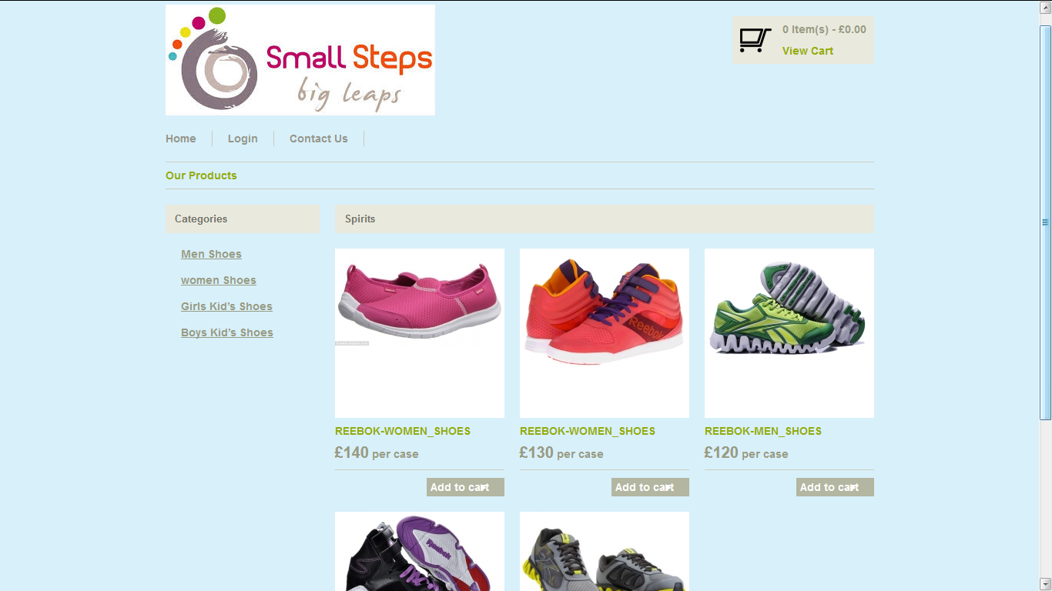

This page is Home Page. And it display different links of the Shoes details and also give information about project user can easily interact with our web site.

* Login Page :-

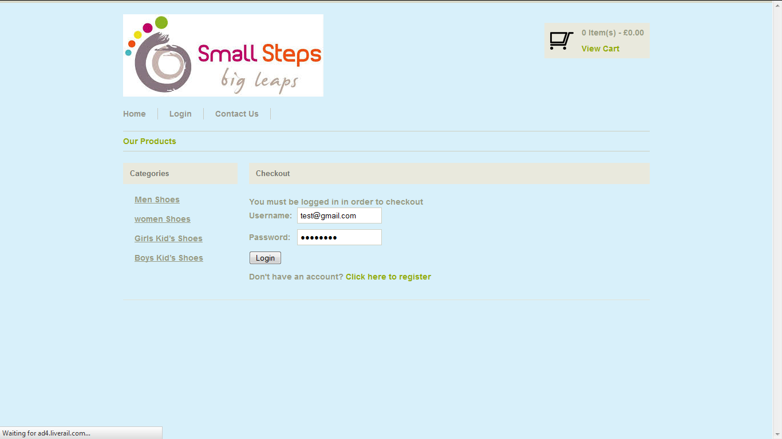

This page is Login Page for user’s login whenever user wants to add any product to cart and if user wants to purchase product then user must login otherwise registration can be compulsory.

* Registration Page :-

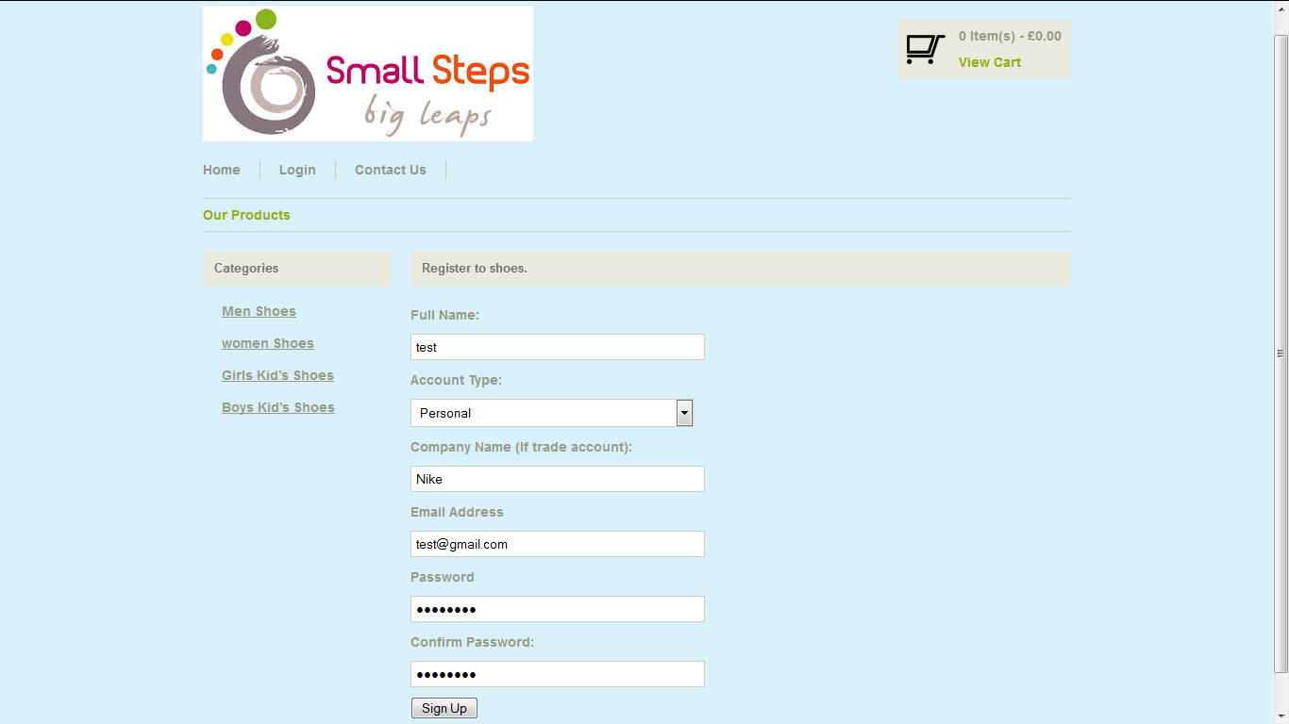

When user wants to purchase and add to cart the product then they can register.

* Add to Cart :-

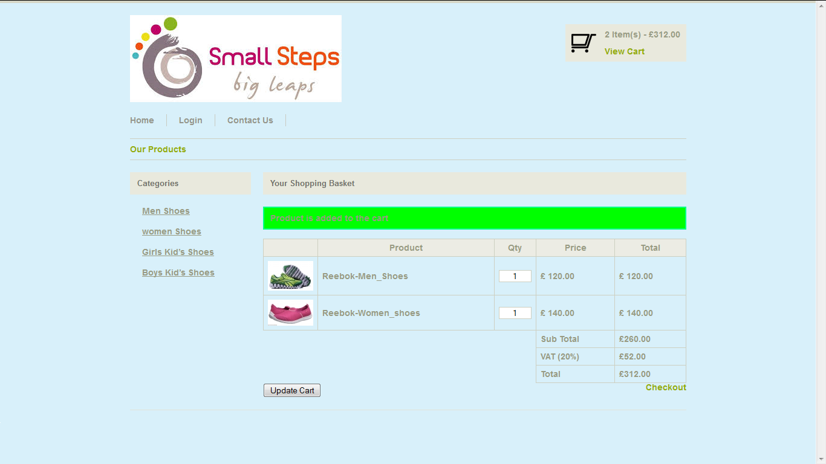

User wants to purchase any product then user can add those products to cart.

* Checkout Page :-

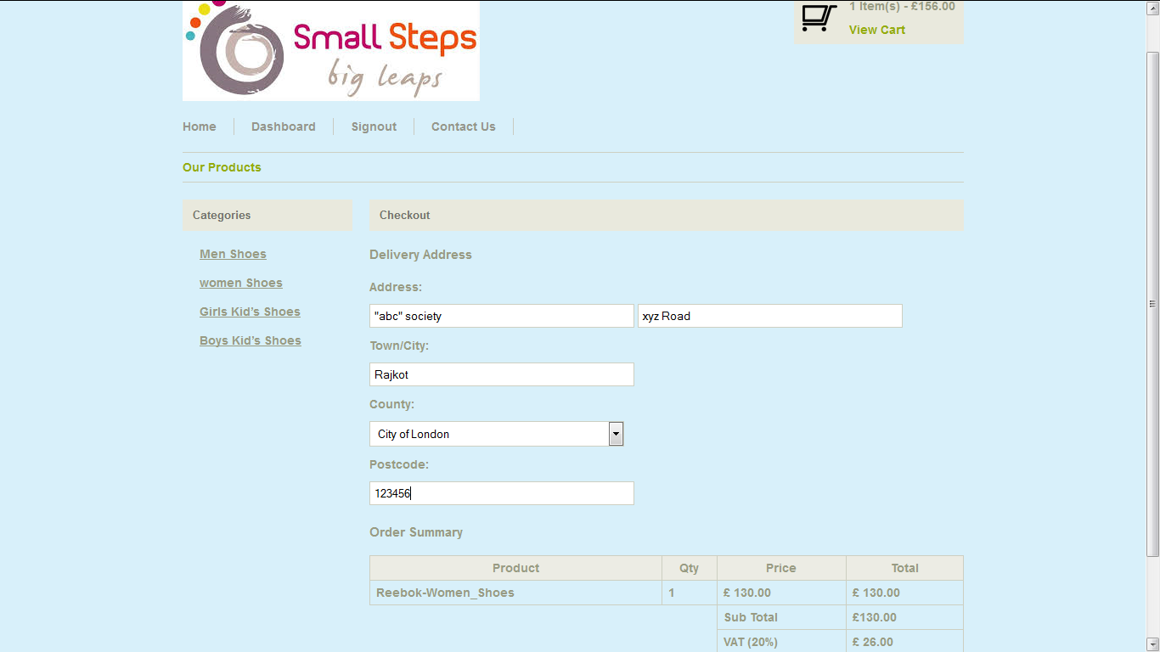

When user wants to purchase and add to cart the product then they can checkout and must login and enter Delivery Address.

* Administrator :-
* **Admin Login Page :-**

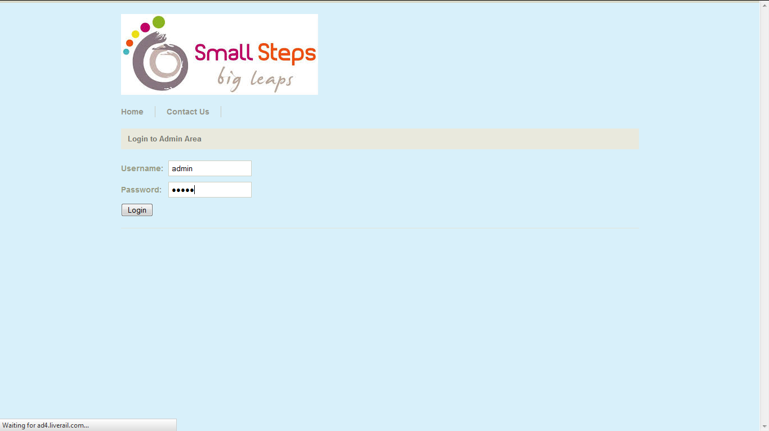

Only Admin can login in these page.

* **Product (Edit, Delete, View) :-**

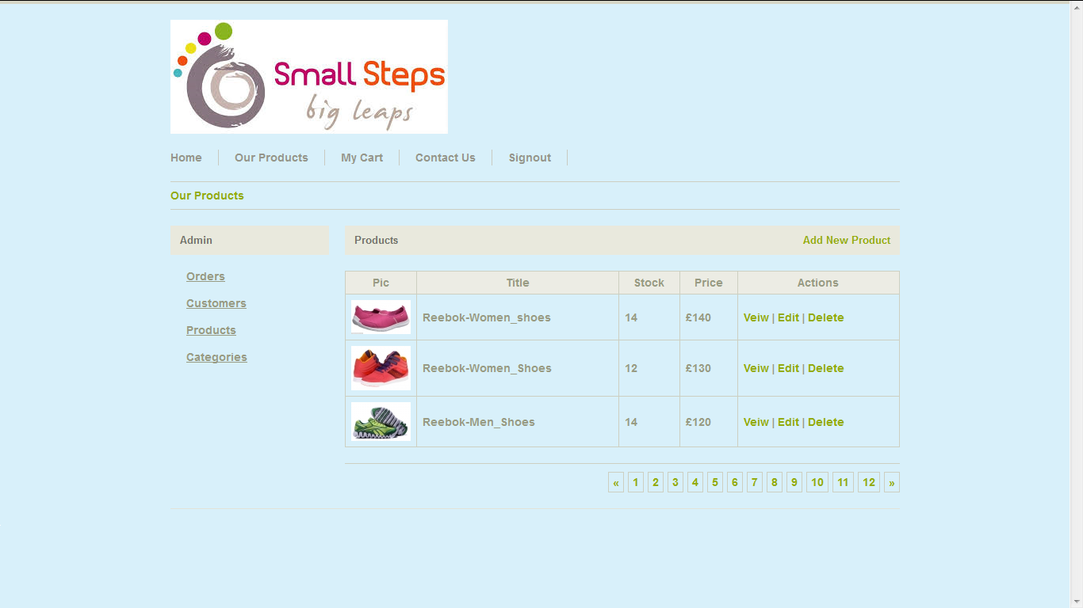

Only Admin can Edit, Delete, View the all products in these page.

* **Categories (View, Edit, Delete) :-**

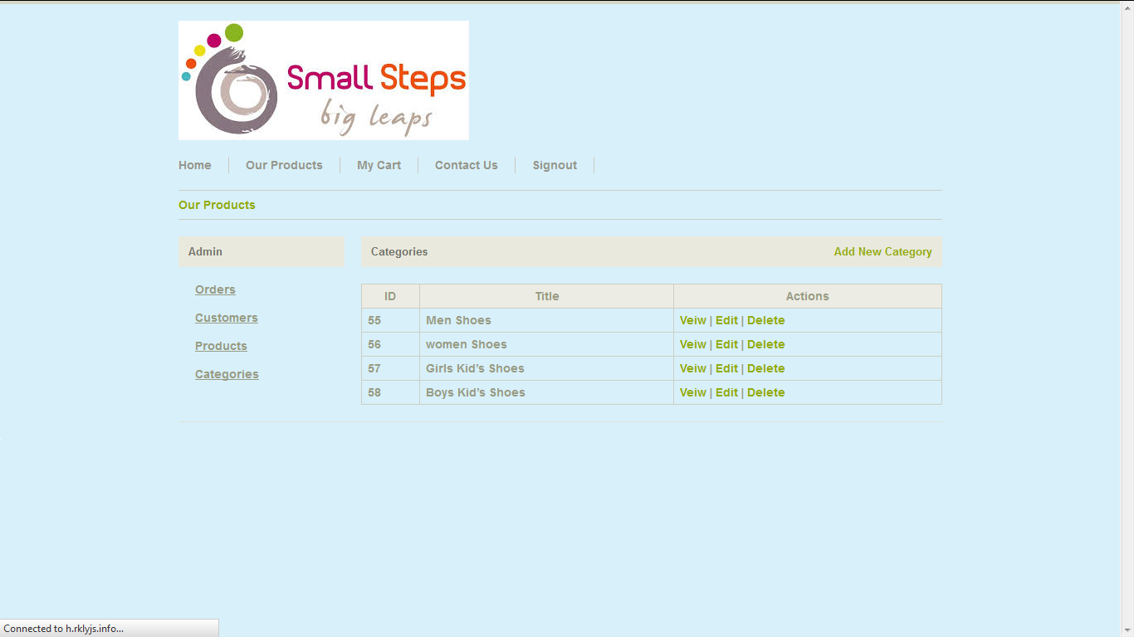

Only Admin can Edit, Delete, View the all categories in these page.

* **Customers (Details, Orders, Edit, Delete) :-**

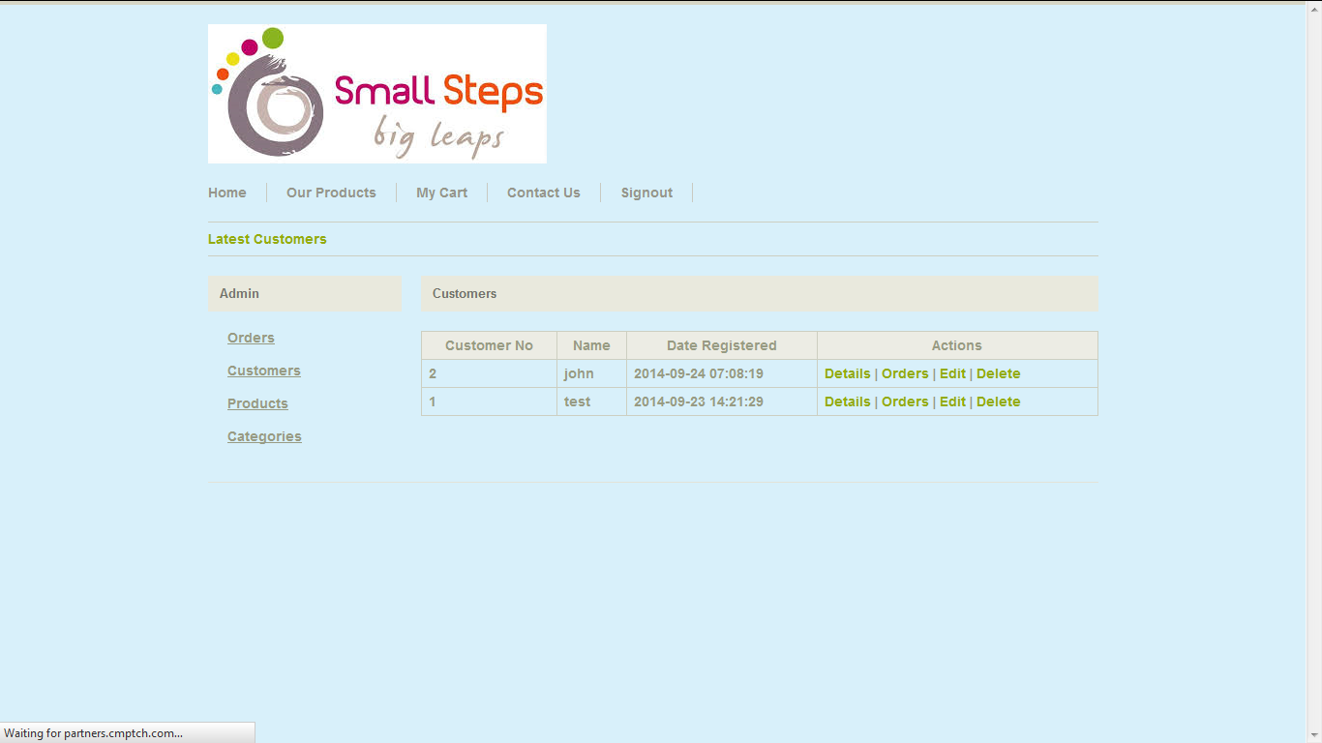

Admin can View Details the all customers and edit, view orders in these page.

1. CONCLUSION

The system is very easy to understand. Anyone can work with it. There is no for a person to have much more knowledge of computer.

System has not been using any kind of bound controls, so no change is required to work from one system to another system.

The coding procedure is very clear. So it is easy to understand. The layout of every form is very good in looking and attractive.

1. BIBLIOGRAPHY
2. HTML & CSS :The Complete Reference

(Publisher: Mcgraw-hill, Author:Thomas Powell)

1. Beginning PHP,apache,MySQL Web Development

(Publisher:Wiley Pub,Author:Jason garner)

1. [www.W3School.com](http://www.W3School.com)
2. [www.google.com](http://www.google.com)